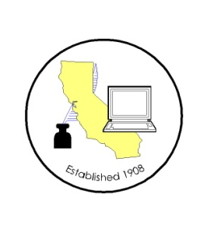
CALIFORNIA ASSOCIATION OF

CLERKS AND ELECTION OFFICIALS

March 16, 2012

TO: CACEO Members, Guests, Legislative Committee

FROM: Deborah Seiler and Jill LaVine, Co-Chairs

SUBJECT: CACEO LEGISLATIVE COMMITTEE MEETING

DATE: FRIDAY, March 23, 2012

TIME: 9:00 a.m. – 3:00 p.m.

LOCATION: County of Sacramento
799 G Street, OCIT – 2nd Floor Conference Room
Sacramento, CA 95814

Subcommittee Meetings, Thursday, March 22, 2012

10 am – Noon Voters with Specific Needs – Tim McNamara

1 pm – 3 pm Board of Directors Meeting – Gail Pellerin

3 pm – 5 pm HAVA/Certification/Voting Systems – Tim McNamara

FRIDAY AGENDA

9:00 am Welcome and Introductions

Approval of January 13, 2012 meeting minutes

Presentation by Andi Liebenbaum (Assembly Member Huffman) on AB 1805

Discussion of New Bills
AB 1626 Yamada
AB 1716 Garrick
AB 1805 Huffman
AB 1814 Eng
AB 1851 Allen
AB 1929 Cook
AB 1979 Roger Hernandez
AB 2191 Norby
AB 2410 Fuentes
AB 2452 Ammiano
AB 2479 Donnelly
SB 1083 La Malfa
SB 1188 Senate Elections
SB 1272 Kehoe
SB 1275 Lieu
SB 1296 and SCA 19 Fuller
SB 1346 Negrete McLeod

AB 1200 (Ma) - Chaptered

Subcommittee Reports

Adjourn

